# Lab S2: Bean Factory Basics

## Objectives

In this lab, you will configure the lifecycle parameters for one of the beans you defined in the previous lab.

## Lab Setup

This lab builds on the previous lab, no additional setup is required. You can start coding from the final state of the code from the last lab.

## Modifying the Java Components

### Step 1: Modify the ITGuru class

1. The only change to be made to the class definition is to add the scope annotation as shown below

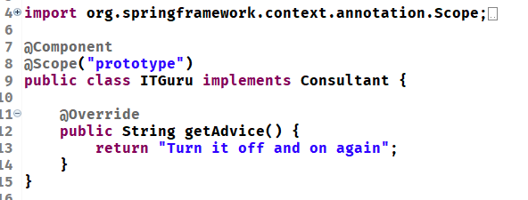

### Step 2: Modify the App

1. In this step, you will modify the code to create two SpinDoctor beans that will both refer to a singleton instance and two ITGuru beans that reference different Java objects because of the @Scope(“prototype”) annotation
2. Printing out the bean in the output statements will print a reference to the memory location where the Java object is that the bean is using
3. The modified code and output are shown below

